**Experiment – 3**

**RELATIONAL MODEL FOR A COLLEGE DATABASE**

**Aim:**

Draw an ER diagram of sailors database.

**Components of ER diagram**

**Entity** – An entity is an object that exists in database administration.

**Attribute** – In DBMS an attribute refers to a database component, such as table.

**Primary key** – A primary key is a specific choice of a minimal set of attributes that uniquely specify a tuple in a relation.

**Foreign key** – A foreign key is a set of attributes in a table that refers to the primary key of another table.

**Composite attribute** – It is an attribute where the values of that attribute can be further subdivided into meaningful subparts.

**Derived attribute** – These are the attributes that do not exist in physical database, but their values are derived from other attributes present in the database.

**Relationship** – A relation as originally defined by E.F. codd. Is a situation that exists between two relational database tables.

**Many to many** – refers to a relationship between tables in a database when a parent row in one table contains several child rows in second table, and vice versa….

**Many to one** – is a type of cardinality that refers to the relationship that A may be linked to many elements of B, but a member of B is linked to only one element of A.

**RELATIONAL MODEL**

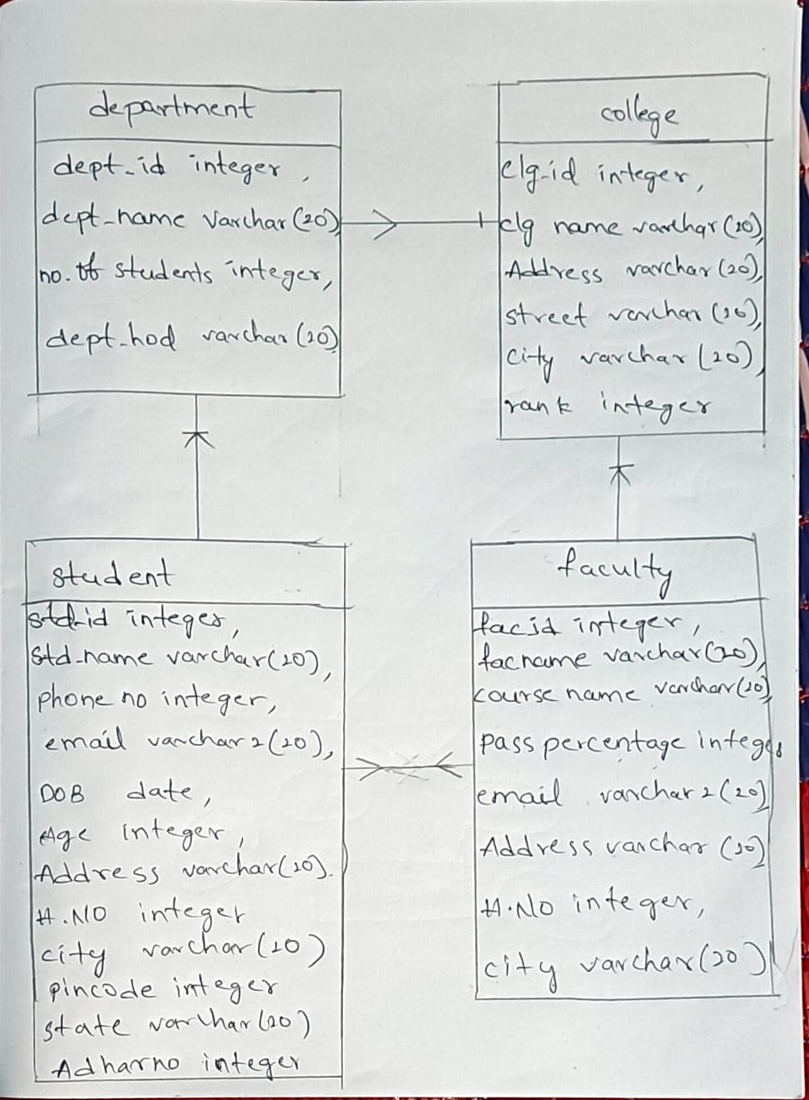

**RELATIONAL MODEL**

COLLEGE

Clg id integer,

Clg name varchar (20),

Address varchar (20),

Street varchar (20),

City varchar (20),

Rank integer

DEPARTMENT

Dept id integer,

Dept name varchar (20),

No. of students integer,

Dept hod varchar (20)

FACULTY

Fac id integer,

Fac name varchar (20),

Course name varchar (20),

Pass percentage integer,

Email varchar2(20),

Address varchar (20),

H.NO integer.

City varchar (20)

STUDENT

Std id integer,

Std name varchar (20),

Phone no integer,

Email varchar2 (20),

DOB date,

Age integer,

Address varchar (20),

H.NO integer,

City varchar (20).

Pin code integer,

State varchar (20),

Aadhar no integer